**Daniel Defense, LLC**

**Corporate Overview**

**Prepared By:**

Joseph Scull, Director of Military and Law Enforcement Sales

1334 Oracal Parkway

Black Creek, GA 31308

912-851-3310

[**jscull@danieldefense.com**](mailto:jscull@danieldefense.com)

DUNS: 130482040  
TIN: 58-2663175

CAGE Code: 3E3E2

NAICS Code: 332994, Small Business, 430Employees

**Introduction**

Daniel Defense, LLC is a world-class firearms manufacturer located near Savannah, GA.  At the turn of the 21st century, firearms enthusiast and lifelong shooter Marty Daniel had multiple concepts and designs that he thought would greatly improve his M16 rifle.  Unable to find them in the commercial market, Mr. Daniel set out to create his own. He began to design and create sling loops and rails in small batches and soon found that the demand for these types of products was much greater than he could have ever expected.

In 2001, Mr. Daniel set aside a small corner of the shop of his other business, located in a small industrial park in Savannah, GA, for Daniel Defense. Only a few short years after its original concept, Daniel Defense is proud to have completed contracts to provide rail systems to the US military through the SOPMOD program.  Daniel Defense also completed a contract with the UK Ministry of Defence, with the goal of upgrading every SA80 rifle military-wide.  So far over 100,000 units have been delivered.

Due to rapid growth, operating space quickly became an issue for Daniel Defense. In May of 2009 Daniel Defense was pleased to welcome customers, guests, friends and family to the Grand Opening ceremony of a new 38,000 square foot facility located in Black Creek, GA.  Three years later, Daniel Defense opened a second facility (92,000 square foot) in Ridgeland, SC.  Both of these facilities allowed for the high rate production of our best in class, rifles, barrels, and rail systems.

With continued growth, in early 2017, Daniel Defense broke ground on a new 300,000 square foot facility in Black Creek, GA that combined both existing facilities. This allowed Daniel Defense to have all resources in one location, assist in growing business expeditiously and bring new jobs to the area. Daniel Defense completed the new company headquarters in December of 2017. This explosive growth has only been achieved through the ability to provide innovative designs that meet and exceed customer needs.

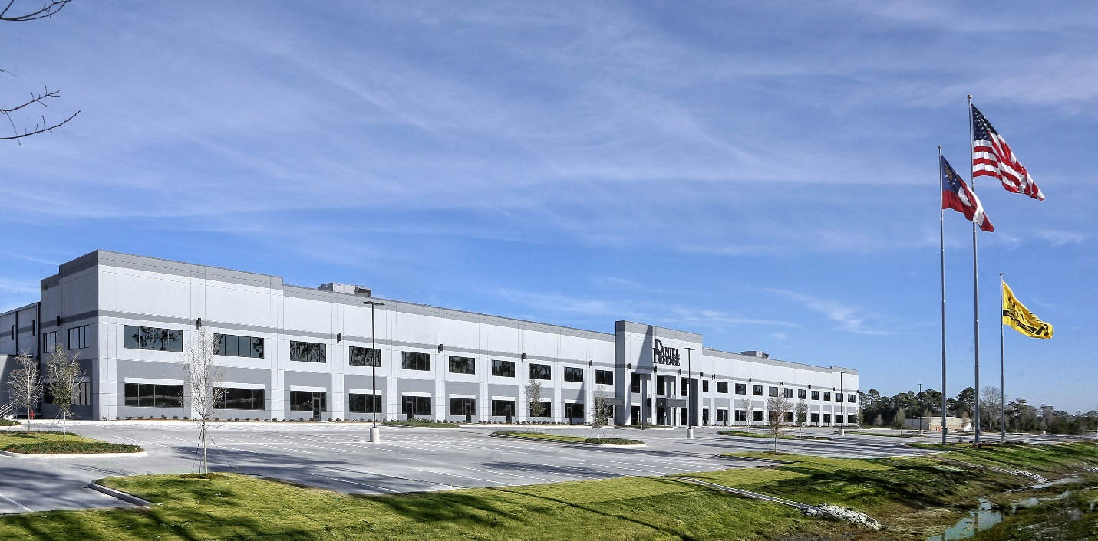

**Figure 1: Daniel Defense Headquarters**

Black Creek, GA

Within the new facility, Daniel Defense has the ability to manufacture nearly all components necessary for firearm assembly. The 2017 expansion allowed Daniel Defense to have total control over the quality of product and to accurately predict production times by combining machining capabilities in one location. The percentage of products manufactured in the United States is 100%. Licensing agreements are not applicable.

In 2024 Daniel Defense produced and sold:

* Over 100,000+ complete weapon assemblies for Military, Law Enforcement, and civilian applications.
* 70,000+ Rail assemblies for weapon assemblies and Military, Law Enforcement, and civilian applications.
* Over 65,000+ barrels for weapon assemblies, upper receiver assemblies and Military, Law Enforcement, and civilian applications.
* Over 350,000+ Daniel Defense associated parts and accessories for weapon assemblies and Military, Law Enforcement, and civilian applications.

1. **Facility**

The Daniel Defense facility houses a state of the art 300,000 square foot production floor, shown in Figure 4, which is responsible for the production of all Daniel Defense products, as well as products of other well respected government suppliers. Daniel Defense currently owns and operates more than 50 vertical and horizontal CNC machines for the production of upper and lower receiver, and handguards as well as various small parts. Production of handguards and rail systems begins with raw aluminum extrusion and proceeds through an advanced manufacturing process which includes built in quality controls. Daniel Defense is among the most well-known rail system manufacturers as evidenced by our past contracts with USSOCOM and the United Kingdom Ministry of Defence for rail systems. Upper and lower receivers are manufactured on Okuma horizontal CNC machines from aluminum forgings. This machinery enables Daniel Defense to mass produce extremely high quality receivers. Members of the Daniel Defense quality assurance team work to ensure that our receivers meet exacting specifications.

Daniel Defense is leading the charge in producing Cold Hammer Forged rifle barrels. Our barrels are the most accurate in the industry, due to cold hammer forging the chamber and rifling at the same time, and we are working to refine our process every day. The Daniel Defense facility houses one of a handful of barrel production cells capable of producing Cold Hammer Forged rifle barrels in the United States. This barrel cell consists of 2 Cold Hammer Forges, multiple CNC lathes, 2 twin spindle Gun Drills, a Magnetic Particle Inspection cell, and a High Pressure Test cell which is unmatched in the small arms barrel production market. Daniel Defense is able to bring in raw steel bar stock and produce thousands of barrels a month in multiple calibers and configurations. This multi-million dollar investment shows Daniel Defense’s commitment to being an industry leader in barrel production.

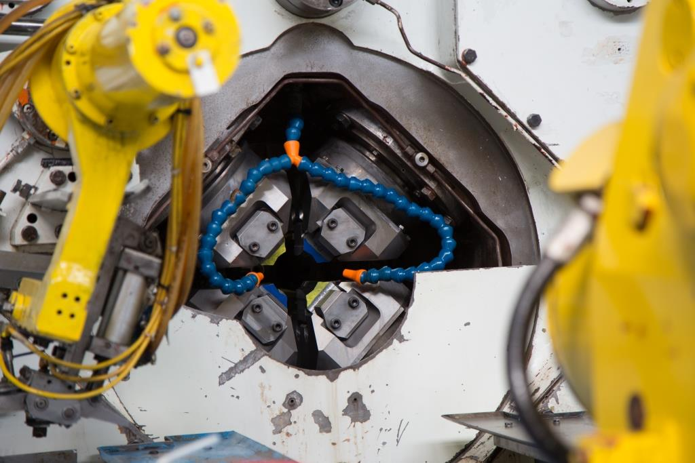

**Figure 2: Cold Hammer Forge**

Daniel Defense barrels go through a multi-phase operation to become a finished rifle barrel. Barrels begin as 4150 Chrome Molly Vanadium (CMV) steel bar stock. Raw materials are inspected and tested to meet Daniel Defense Quality standards. Bar stock is cut to length on a CNC saw. Next a gun drill is used to bore through the bar stock to a diameter slightly greater than the finished chamber dimension. The bar stock is then turned on a lathe to a profile used within the hammer forge machine, a hone polishes the interior surface to ensure a clean smooth interior dimension prior to forging. Next the bar stock is forged into a rifles barrel. On the hammer forge machine a mandrel is inserted into the bore and four hydraulic hammers compress the material onto the mandrel forming the bore and chamber.

Daniel Defense is one of very few manufactures that forge the bore and chamber in one process leading to perfect bore and chamber alignment. This is critical to achieve the accuracy results that Daniel Defense barrels are known for. The forge is also programmed to create a tapered bore, which tapers inward from the chamber to the muzzle resulting in better velocity and accuracy. Once forged the barrels are sent to one of three barrel finish turn lines where the barrels are cut to length and profile, threaded, and have gas ports drilled. Barrels are then high pressure and magnetic particle inspected. Next the barrels are chrome lined and phosphate coated to ensure durability and corrosion resistance. At each phase of the operation barrels are checked 100% for all critical dimensions. This includes chamber dimensions, headspace, bore diameter, and straightness. Daniel Defense barrels are also laser mapped to ensure proper dimensions throughout. Upon completion barrels are proof tested, and all chambers and feed ramps are hand polished.

Daniel Defense has an experienced, dedicated barrel manufacturing team. Rob Pohl is the Vice President of Manufacturing and is responsible for the barrel manufacturing cell. Rob has been with Daniel Defense for 13 years and was heavily involved in setting up Daniel Defense’s cold hammer forging operation. Rob has more than 40 years of experience in various areas of manufacturing including mold and die, aerospace, automotive, and small arms.

Clayton Hilliard is a manufacturing engineer responsible for programming the hammer forge machine, testing, and evaluation the manufacturing process. Clayton holds and M.S. in mechanical engineering and has worked at Daniel Defense for 11 years. Clayton was part of a team from Daniel Defense involved in the initial set up of cold hammer forging at the Daniel Defense facility and spent time in Germany training with a manufacturing partner with more than 40 years of cold hammer forging experience.

Wesley Hunko is a manufacturing engineer in the Daniel Defense barrel cell. Wesley holds a B.S., M.S, and Ph.D. in mechanical engineering from Auburn University. Prior to working at Daniel Defense Wesley worked in an additive Manufacturing Design Guidelines for Space Launch Systems for Boeing and NASA, and was a head teaching assistant/teacher for the manufacturing lab at Auburn University. Wesley also worked as a Manufacturing Engineer for auto industry fixtures. Wesley has been with Daniel Defense for almost 3 years. His impressive education and experience provide Daniel Defense with an excellent resource to ensure quality barrel production.

Daniel Defense houses equipment needed to manufacture all steel components for Daniel Defense rifles and other products.  A large variety of Okuma Swiss screw machines, horizontal and vertical CNC machines, CNC lathes and grinders are used for machining small parts.  This includes bolt carrier groups, flash suppressors, and gas blocks along with small parts needed for firearm assembly. The Daniel Defense production process includes quality control measures completed as parts are finished on the machine to ensure compliance with part specifications.

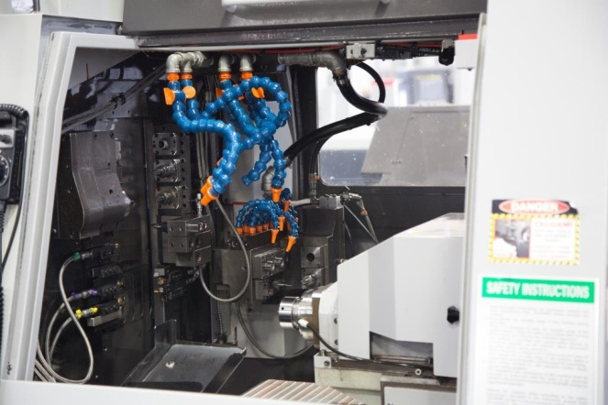Once assembled by our team of 14 trained armory personnel, firearms are function tested in purpose built test fire ranges. Two ranges are utilized to check both function and accuracy.  The indoor function test range is a 25 yard facility where each Daniel Defense firearm or upper receiver is tested with live ammunition.  The accuracy test fire range is a state of the art 100 yard range which uses acoustic sensors to determine ballistic data.

Daniel Defense operates an on-site secure storage facility with limited security access controls. The secure area, which is located in our new production facility, is approximately 24,000 square feet. In this area we have the ability to securely store a minimum of 9,800 complete rifles in addition to all other raw materials, components, accessories and ammunition.

**Figure 3: Tsugami Swiss Screw Machine**

1. **Quality Assurance**

Daniel Defense prides ourselves on the quality of product we produce and supply to our customers, and are proud to provide an in-depth Quality Control program that ensures all receivers, barrels, rails, hardware, and accessories are inspected to rigorous standards that either meet or exceed the sampling procedures set by ANSI/ASQ Z1.4-2003 (R2013). During our state of the art machining process all parts are subject to an in-process inspection of critical dimensions identified by our Design Engineering Team. In process inspections are conducted by trained operators and Quality Representatives throughout the process at a frequency defined by the Quality Team. All in-process inspections are documented and signed by the inspector, and the documentation is retained with the production work orders.

Daniel Defense remains on the cutting edge by utilizing state-of-the-art inspection equipment. We currently operate multiple Coordinate Measuring Machines (CMM), Microview Machines, and Optical Comparators. Daniel Defense also uses a wide variety of specialty gauges and measuring instruments which are routinely inspected for conformity and accuracy.

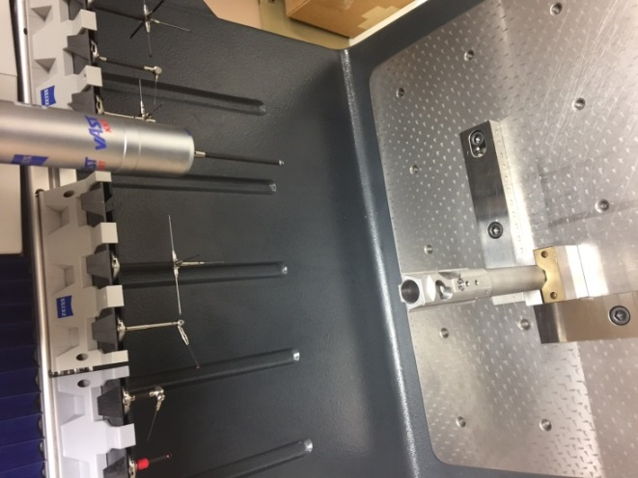All incoming material is controlled by processes defined in our internal operating procedure QP-012. Any rejected material is issued a Non-Conformance Red Tag, removed from the production work order and quarantined for disposition by the appropriate design authority.

At Daniel Defense each weapon undergoes a multi-point inspection process during assembly. Our upper and lower receiver groups are assembled and 100% inspected by certified Daniel Defense Armorers. The Quality Assurance Armorer Representative then conducts an in depth full-function test of the weapon. Once the weapon has been inspected and declared fully functional it is test fired by a Daniel Defense Certified Range Lead. Each Daniel Defense Range Lead is a certified Daniel Defense Armorer, and National Rifle Association Range Safety Officer. Once the weapon meets the Daniel Defense standard it receives a Quality Assurance tag initialed by each inspector during the process, and it accompanies the weapon when packaged.

**Figure 4: Coordinate Measuring Machine**

Daniel Defense having an extensive safety program managed by Sean Polwort, we meet or exceed all OSHA standards and have an excellent safety records.